GlobalLink Project Director

*Automate the change management of localization processes and resources.[1]*

The GlobalLink platform helps streamline the process of managing complex localization requirements for both online and offline content.

Here is a new sentence to help showcase automatic translation.

GlobalLink 6 provides powerful business process automation, flexible integration capabilities, translation vendor management and project workflow capabilities in an intuitive, web-based platform. As the flagship application of the GlobalLink platform, Project Director can be easily configured to meet any enterprise translation requirements.

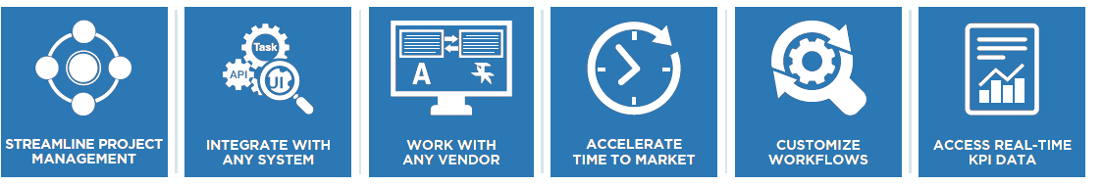

Key Advantages

**SEAMLESS DATABASE INTEGRATION**  
Use GlobalLink Connect with any CMS, PIM, CCMS, or e-commerce platform

**VENDOR-NEUTRAL PLATFORM**  
Allow access to any vendor or internal translator for maximum resource flexibility

**WORK WITH ANY FILE FORMAT**  
Next-generation parsing engines extract content and prepare it for translation

**CONFIGURABLE WORKFLOW**  
Streamline your translation process through automation of manual tasks

**TRANSLATION MEMORY INTEGRATION**  
Maintain brand consistency and save on repeat translations

**ENTERPRISE REPORTING**  
View virtually any set of data points in real time to gauge translation efficiency

**UNIFIED DASHBOARD**  
Track all projects in real time across the enterprise so you never miss a deadline

**FLEXIBLE DEPLOYMENT MODELS**  
Install on-premise or deploy in the cloud without sacrificing functionality

1. This is a test footnote